744 P Street, Sacramento, CA 95814 www.cdss.ca.gov

August 30, 2012

SUBJECT: CASE MANAGEMENT AND INFORMATION PAYROLLING SYSTEM II (CMIPS II) WORKAROUNDS FOR GROUP 3

BACKGROUND

As CMIPS II conversion continues, errors have been found. Because of the scale of the system, addressing the issues cannot always be addressed in a timely manner. In many cases workarounds have been designed to help users accomplish certain tasks until such time as a permanent fix can be made.

The attached document describes the most up to date list of these fixes.

Sincerely,

The California Department of Social Services
Paul Cooper
Revised 8/21/2013

Revision History
Version | Date | Status | Author | Comment
1.0 | 1/11/2013 | Draft | Kelly Elo
1.1 | 1/28/2013 | Webinar Version | Kelly Elo
1.2 | 2/4/2013 | Webinar Version | Kelly Elo | Revision from 1st Webinar Feedback
1.3 | 4/15/2013 | Webinar Version | Lorna Burke | Updated document for Group 2 webinars
1.4 | 5/17/2013 | Webinar Version | Lorna Burke | Updated document to remove Transfer/Rubbing Skin workaround
1.5 | 8/21/2013 | Group 3 Updates | Paul Cooper | Updated document for Group 3 webinars
Contents
Summary 5
Workarounds: 6
823 Payment Correction Does Not Cutback Hours 6
SR4466 – Rescinding a Case that has a Companion Case (s) and Protective Supervision 6
NOA’s 8
620 – DN 12 NOA when NO Assessed Need when met by Refused or Alternative Need. 8
538 – Reprint in NOA in Other Language 8
652 –Modify Living Arrangement 9
669 - Fingerprint Exemption 10
State Hearings 11
597 – NOA SHO1 11
624 – Remove 10 day notice for SH02 11
639 – Correct Erroneous State Hearing Record 12
753 – Negative Action Requires 10 day Notice for SHO1 and HR04 NOAs 16
606B - ICT Cannot be Assigned to Case Owner Requiring Supervisor Approval 17
Spec Transactions/Payments 18
649 – Provider Spec Transactions 18
Reports 19
Forms 20
Other 22
550 – Advance Pay Overpayment Information Collection 22
Informational: 23

Summary
 |  | New Work | Manual Process | UPDATE
NOA's (NOA message apply to specific cases not ALL case) | Min.
620 - DN12 NOA Message Trigger | 2 | x
538 - NOA Reprint in Other Language than Originally printed |  |  | x
Eligibility/Assessments
I-5877 - Medical Eligibility/Pending Cases - require 2 assessments | 2 | x |  | Removed
751 - P.O. Box when person has both Recipient & Provider type | 15 | x |  | Removed
669 - Fingerprint Exemption | 1 | x
652 - Modify Living Arrangements Table | 1 | x
823 Payment Correction Does Not Cutback Hours | 3 | x | x | Added
SR4466 - Rescinding a case that has a companion case (s) and Protective Supervision | 5 |  | x | Added
State Hearings
753 - Both SH01/HR04 NOAs hearing upholds neg action reqs 10 day | 3 | x
642 - Aid Paid Pending NOA Msg not included | 5 | x
639 - Ability to correct erroneously entered State Hearings Record | 1 | x
624 - Remove 10 day notification SH02 NOA | 3 | x
597 - Changes to NOA SH01 in all languages |  |  | x
Inter-County Transfer (ICT)
752 - ICT case cannot be assigned to case owner w/sup approval | 2 | x
606A - Remove ICT Phone Number Match Edit
606B – ITC Cannot be assigned to case Owner requiring Supervisor approval
Special Transactions
649 - Provider Payment Spec Transaction - County Information | 5 | x
Reports
673 - Add SSN status to Provider Enrollment Report |  |  | x
637 - County Statewide View of Reports | 2 | x
591 - Query & Sampling Tool Solution |  |  | x
529 - Add sort order on Provider Payment Summary Report | 2 | x
489 - Detail for Referrals by Source by County & District Office |  |  | x
488 - Include comments on the Disaster Preparedness Report |  |  | x
Forms (Available on CDSS Website)
661 - Forms Pre-Population, Field length Corrections |  |  | x
631 - Remove SCIF e3067 |  |  | x
526B Forms |  |  | x
442 - Legislative Change 2009, SOC847 |  |  | x
784 – Changes Needed to SOC 293 form
OTHER
550 - Advance Pay Overpayment Collection Information | 5 | x

Workarounds:

823 Payment Correction Does Not Cutback Hours

NOTIFICATION
When processing payment correction and the provider claims hours exceeding the IP Mode of Service hours, CMIPS II does not cut back hours entered by the user.

What To Do
Counties should manually reduce the timesheet hours by the amount over the recipient authorized hours. The reduction should start with the latest day in the pay period and work backwards. Then, enter only the eligible hours to be processed in CMIPS II.

Example:
IP Mode of Service Hours = 23:00
Timesheet Part B, Total Hours claimed = 32:00

Original Timesheet
Days of Mos | 16 | 17 | 18 | 19 | 20 | 21 | 22 | 23 | 24 | 25 | 26 | 27-30
HH:MM | 00:00 | 05:00 | 05:00 | 02:00 | 03:00 | 04:00 | 01:00 | 02:00 | 03:00 | 05:00 | 02:00 | 00:00

Corrected Hours for entering in Payment Correction
Days of Mos | 16 | 17 | 18 | 19 | 20 | 21 | 22 | 23 | 24 | 25 | 26 | 27-30
HH:MM | 00:00 | 05:00 | 05:00 | 02:00 | 03:00 | 04:00 | 01:00 | 02:00 | 01:00 | 00:00 | 00:00 | 00:00

NOTIFICATION

SR4466 – Rescinding a Case that has a Companion Case (s) and Protective Supervision
NOTIFICATION
When an attempt is made to rescind a terminated case which is also a companion case and has Protective Supervision Proration set to Yes; an error message displays preventing the rescind action. The error message is ‘All companion cases associated with this case must have pending evidence or active evidence with IHSS determination date within one business day of current date when any companion case PS proration = yes. Please update case evidence as needed.’
This message appears because when the rescind action processes, the system creates a “new authorization” segment. This new authorization requires all the companion cases to have either Pending Evidence or Active Evidence which has been authorized within one business day of the case action which is being taken. This ensures the proration of protective supervision is calculated accurately on all companion cases.
Scenario:
CASE A | CASE B
Status = Eligible  Protective Supervision  PS Proration (on Household Evidence) = Yes | Status = Terminated  Protective Supervision  PS Proration (on Household Evidence) = Yes
What To Do
Eligible Companion Case
- Create Pending Evidence to the case
- On the Program Evidence, enter the same Authorization Start Date that was on the previous assessment.
- Process Check Eligibility but DO NOT Submit for Approval.
Terminated Companion Case Pending Rescission
- After Pending Evidence is added to the Eligible Status Case, navigate to the terminated case.
- From the Case Home screen on the terminated case, process the Rescind action.
Eligible Companion Case
- If appropriate, navigate back to the Evidence Workspace on the eligible case in step 1 and delete the Pending Evidence.

NOA’s

620 – DN 12 (NO Assessed Need) Triggered When Need Is Met By Refused or Alternative Services.
NOTIFICATION
Currently when assessed need is indicated as a Refused Service or being met by Alternate Resource, NOA message DN 12 - No Assessed Need is being triggered along with DN14 - Need Met by Alternate Resource or Refused Service.
WHAT TO DO
The county has the option for staff to cross out the DN 12 wording "no assessed need" on the NOA after printing prior to mailing.
ADDITIONAL RESOURCES
- Handbook: Section 4.4.6
- CMIPS II Screen: NA
- Training Materials: Job Aids

538 – Reprint in NOA in Other Language
NOTIFICATION
In CMIPS II there needs to be a way for a user to reprint a NOA in a language different than the original language in which it was printed.
WHAT TO DO
If the NOA was not issued in the recipient’s preferred written language, continue the current manual process. The user will print a Notice of Action template in the recipient’s correct language from the CDSS website and send that blank template with the incorrect language NOA printed from CMIPS II. The user will provide the recipient with the NOA messages in the correct language as an attachment to the blank NOA template. The translated NOA messages are available in the CMIPS II Threshold Languages NOA Messages spreadsheet.
ADDITIONAL RESOURCES
- Handbook: Section 1.6.1
- CMIPS II Screen: NA
- Training Materials: NA
- User’s Manual: NA
- CMIPS II Threshold Languages NOA Messages Spreadsheet (Worksite Web #9921)

652 –Modify Living Arrangement
NOTIFICATION
The Living Arrangement Code Table currently indicated two separate entries: Tenant, and Landlord. This Change Request (CR) requests that these two entries be combined to “Tenant/Landlord” and that the remaining value be removed. The Landlord option will be removed. The Tenant Option will be Tenant/Landlord.
WHAT TO DO
When selecting the Living Arrangement on the Household Evidence screen, the user will choose "Tenant" when appropriate for the recipient/applicant living arrangement. The "landlord" option from the drop down should not be used and will be removed when CR 652 is implemented.
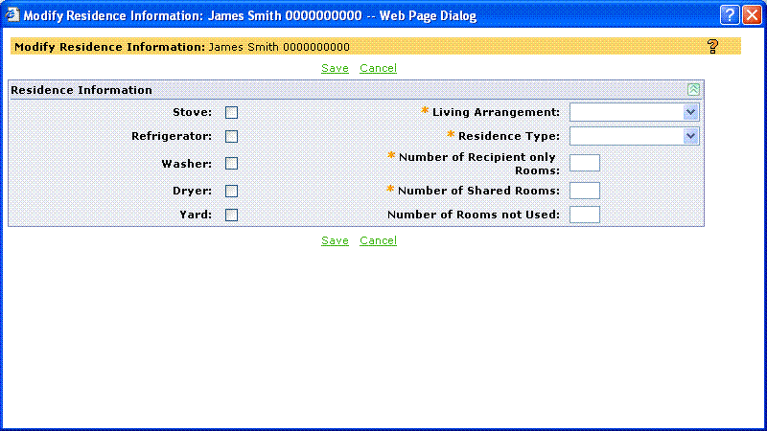
ADDITIONAL RESOURCES
- Handbook: Section 4.4.1
- CMIPS II Screen: Modify Residence Information (within Household Evidence)
- Training Materials: Module 6 (Service Eligibility/Final Determination) / WBT: Determine Program Eligibility course
- User’s Manual: Chapter 3 (Recipient Management); Section 4.6 (Household Evidence)

669 - Fingerprint Exemption
NOTIFICATION
New Legislation repealed the 2009-10 Legislation that required Recipient Fingerprints as a term of eligibility for IHSS. CMIPS II requires an entry in the Fingerprint Exemption field in order to continue with IHSS eligibility.
WHAT TO DO
When creating a referral or application, users will select "Fingerprint Equipment Unavailable" from the drop down list for the Fingerprint exemption field.
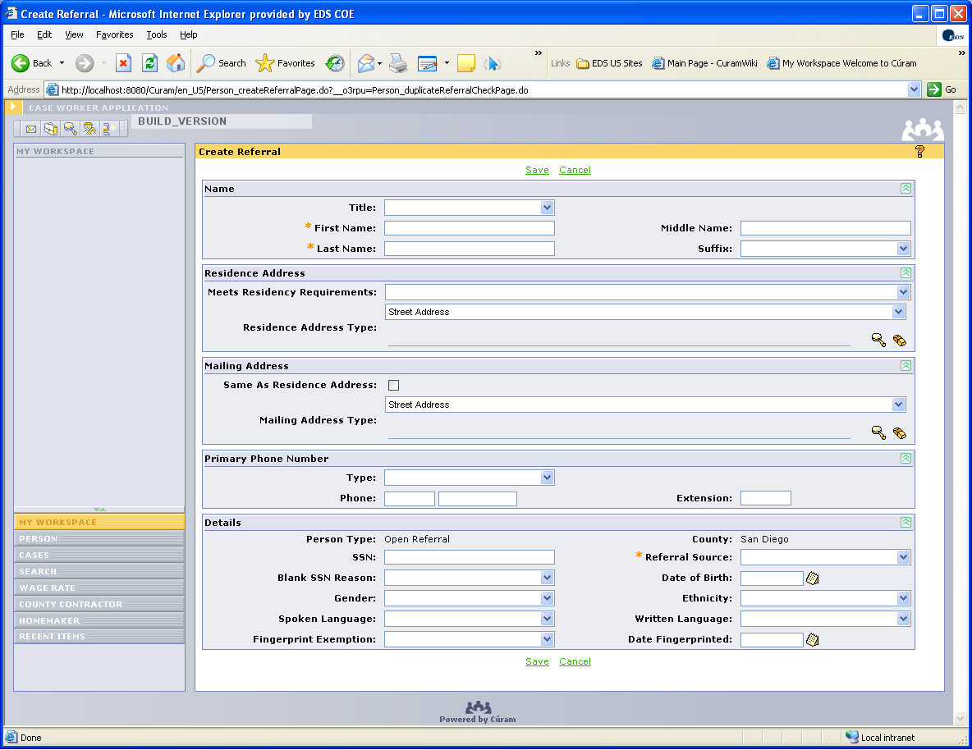
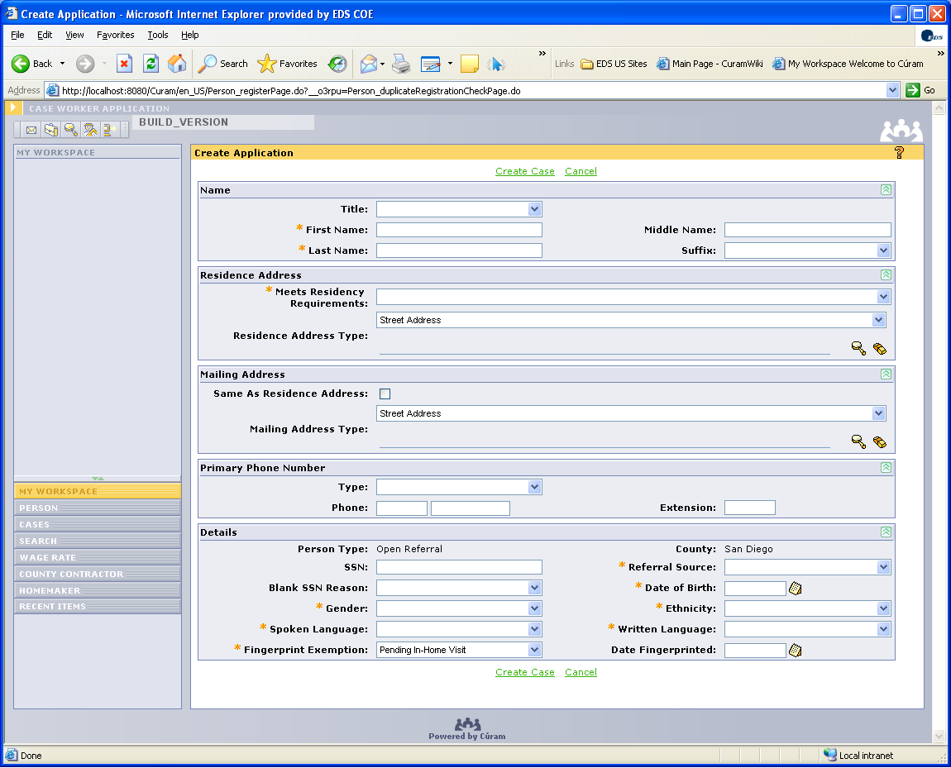
ADDITIONAL RESOURCES
- Handbook: Section 3.5
- CMIPS II Screen: Create Referral or Create Application
- Training Materials: Module 5 (Initial Contact/Intake Application) / WBT: Case Intake course
- User’s Manual: Chapter 3 (Recipient Management); Section 2.2 (Create an Application)

State Hearings

597 – NOA SHO1
NOTIFICATION
The NOA text for message NOA SH01 (State Hearing – Outcome Compliance) contains the word ‘dated’ which needs to be removed. Removal of this word needs to be done in all language versions of this NOA. Change NOA message to "This NOA reflects the outcome of your state hearing." from previous "This NOA reflects the outcome of your state hearing dated."
WHAT TO DO
The county has the option for staff to cross out the word "dated" on the NOA after printing prior to mailing.
ADDITIONAL RESOURCES
- Handbook: Section 6.4.1
- CMIPS II Screen: Modify Manual NOAs (within Program Evidence); Authorization Summary (to view NOA messages generated)
- Training Materials: Module 6 (Service Eligibility/Final Determination) / WBT: Determine Program Eligibility course / Job Aids
- User’s Manual: Chapter 3 (Recipient Management), Section 4.8 (Program Evidence) and Section 5.2 (View an Authorization Summary)

624 – Remove 10 day notice for SH02
NOTIFICATION
The California Department of Social Services (CDSS) requests the 10-day notification be removed from the SH02 Notice of Action (NOA) (State Hearing - Conditional Withdrawal) message.
WHAT TO DO
The user WILL NOT select the SH02 manual NOA. The user has two options:
- As part of the entry of Assessment evidence, the user has the ability to select a Manual NOA freeform text message which will allow for the "cut and paste" from the CMIPS II Threshold Languages NOA Messages spreadsheet into the NOA Freeform text field and finish completing the evidence.
- Print the SH02 NOA message from the CMIPS II Threshold Languages NOA Messages spreadsheet and attach it to the NOA printed NOA.
ADDITIONAL RESOURCES
- Handbook: Section 6.4.1
- CMIPS II Screen: Modify Manual NOAs (within Program Evidence); Authorization Summary (to view NOA messages generated)
- Training Materials: Module 6 (Service Eligibility/Final Determination) / WBT: Determine Program Eligibility course / Job Aids
- User’s Manual: Chapter 3 (Recipient Management), Section 4.8 (Program Evidence) and Section 5.2 (View an Authorization Summary)
- CMIPS II Threshold Languages NOA Messages Spreadsheet (Worksite Web #9921)

639 – Correct Erroneous State Hearing Record
NOTIFICATION
Currently, a user has no recourse when an error is made and a State Hearings record is erroneously entered for a case. he State has a business need to be able to identify the entry as erroneous and to preclude it from being reported on the reports associated with State Hearings.
WHAT TO DO
User should set the Outcome to “Dismissal” and add a note to the Case Notes indicating the date and the State Hearing record entered in error.
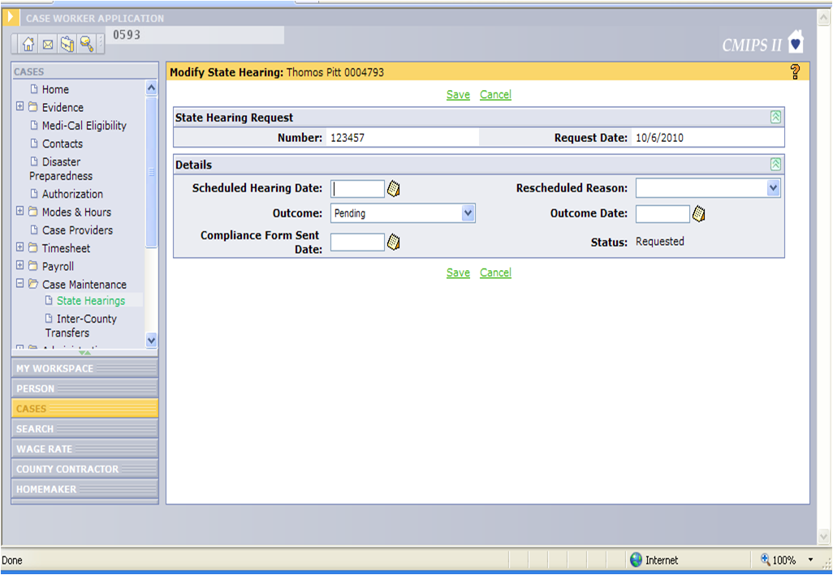
ADDITIONAL RESOURCES
- Handbook: Section 6.5
- CMIPS II Screen: Modify State Hearing
- Training Materials: Module 7 (Case Maintenance) / WBT: Case Maintenance course
- User’s Manual: Chapter 3 (Recipient Management); Section 6.5 (State Hearings)
642 – Aid Paid Pending State Hearing
NOTIFICATION
Currently aid paid Pending NOA messages are not in CMIPS II. Additionally CDSS has provided direction to counties on how to authorize aid paid pending.
When an IHSS recipient appeals discontinuance, decrease of service hours, or any negative/adverse action and qualifies for aid paid pending, CDSS has provided direction to use the assessment type of State Hearing to restore services. Additionally when the negative action includes a combination of services for which some hours were reduced and some were increased, case owner will restore only services where hours were reduced. Services where hours were increased will not be restored or changed. This will result in an overall increase to the monthly authorized to purchase hours, allow for services to be authorized retrospectively and issue timesheets to the provider(s) for the retrospective pay period(s).
SCENARIO
Recipient Joan’s IHSS ATP hours were reduced from 100 to 85. With the reduction, dressing and range of motion were decreased by 25 hours while ambulation services were increased by 10 hours. Recipient Joan appealed the decreased services and qualifies for aid paid pending. In CMIPS II, the case owner creates a State Hearing assessment and restores hours for dressing and range of motion back to 25 hours while hours for ambulation services remain at 10 hours.
WHAT TO DO
- Before starting, compare the prior assessment to the assessment for which the recipient is appealing. Then, note the following:
  - Service(s) and its associated time where reduction was assessed
  - Authorization start date of the active assessment for which the recipient is appealing
- In CMIPS II, create pending evidence with assessment type of State Hearing
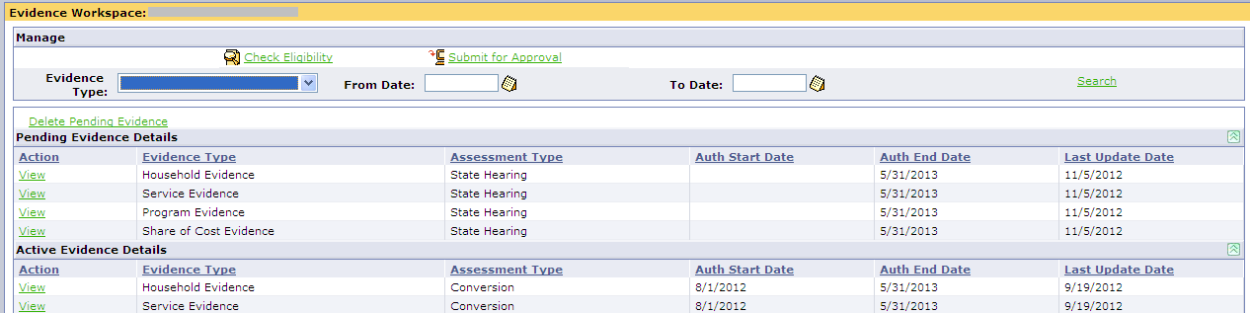
- From the Evidence Workspace, select the View link associated with Service Evidence. When the Service Evidence screen displays, select the Edit link associated with the service type(s) identified in step 1a and enter the new time as reflected in step 1a.
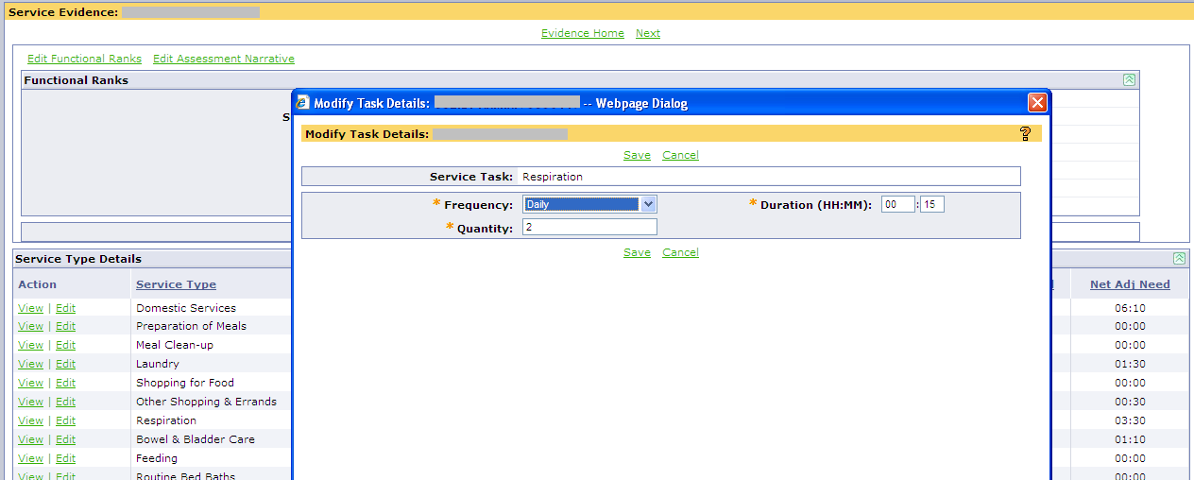

- From the Program Evidence screen, select the Edit Program Evidence link, the Modify Program Evidence screen displays. Refer to “user action” below for screen completion and then save the screen.
Field | User Action
Authorization Start Date: | Enter date noted in step 1b
Waiver Program: | If blank, select as appropriate
Other fields: | No change

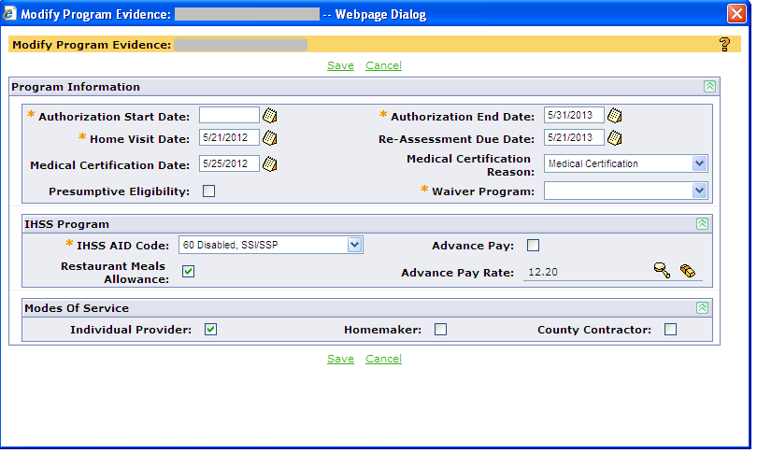
- From the Program Evidence screen, select the Add/Edit NOAs link and refer to “user action” below.
NOA Code | User Action
*FF01 | Select
Freeform text: | *Using the CMIPS II Threshold Languages NOA Messages spreadsheet or the Legacy CMIPS 2000  User’s Manual, copy and paste the appropriate aid paid pending NOA message into this field Remembering that the FF01 text field only allows 200 characters.
*This is a work around until Aid Paid Pending NOA messages are released into CMIPS II.

- Complete the remaining Household and Share of Cost evidences as necessary.
- Process check eligibility. From the Authorization Summary screen, verify service(s) identified in step 1a are restored and FF01 is listed. Then, submit for approval.
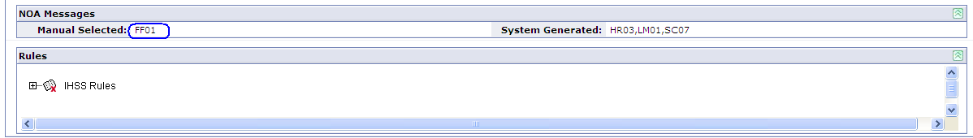
CONTACT
If you have any questions or need further clarification regarding this CMIPS II Informational Notification, please contact the CMIPS II Help Desk at 1-(877)-844-5844.
ADDITIONAL RESOURCES
- Handbook: Section 6.2
- CMIPS II Screen: Evidence Workspace (to get to all screens to modify services back); Modify Manual NOAs (within Program Evidence) to add freeform text
- Training Materials: Module 7 (Case Maintenance) / WBT: Determine Program Eligibility course
- User’s Manual: Chapter 3 (Recipient Management); Section 4.8 (Program Evidence)

753 – Negative Action Requires 10 day Notice for SHO1 and HR04 NOAs
NOTIFICATION
Both the SH01 - State Hearing – Outcome Compliance, and HR04 - Assessed Hours decrease NOA messages are generated when complying with a state hearing decision and thus requires a 10 day notice. Current practice and policy is that because the recipient receives the hearing decision from the ALJ, no HR04 NOA message is needed and 10 day notice is not required – they received that notice the first time.
WHAT TO DO
Set the Authorization Start Date on Program Evidence to a date at least 13 days in the future to accommodate the business rules requiring 10 day notice.
ADDITIONAL RESOURCES
- Handbook: Section 6.4.1
- CMIPS II Screen: Modify Manual NOAs (within Program Evidence); Authorization Summary (to view NOA messages generated)
- Training Materials: Module 6 (Service Eligibility/Final Determination) / WBT: Determine Program Eligibility course / Job Aids
- User’s Manual: Chapter 3 (Recipient Management), Section 4.8 (Program Evidence), Section 5.2 (View an Authorization Summary

606B - ICT Cannot be Assigned to Case Owner Requiring Supervisor Approval
NOTIFICATION
Defect #4485 - When a Case is in Inter-County Transfer (ICT) Status, the receiving County ICT Coordinator assigns a Case Owner to complete the ICT Assessment. If the case owner requires supervisory approval, on "submit for approval" the user/case owner receives the following error: "You do not have the required privileges to maintain this data" and the ICT Assessment cannot be submitted. This only happens when the user/case owner requires supervisory approval. Cause: Case is still "owned" by Sending County until transfer is complete.
WHAT TO DO
Receiving County should assign ICT cases to case owners who do not require supervisory approval for completion of ICT assessment. On completion of the transfer, when the case is no longer in ICT status, the case can be reassigned to a case owner who requires supervisory approval:
- From the ICT work queue, select the View link associated with the ICT. The Task Home screen displays.
- From the Task Home screen, select the hyperlink in the Primary Action section to navigate to the Case Home screen.
- From the left navigation menu, navigate to the Inter-County Transfer screen and assign a worker to the ICT.
Note: When the assigned worker is designated successfully on the Modify ICT screen, the system closes the ICT task regardless of where the task is currently located (ICT work queue or reserved tasks folder).
ADDITIONAL RESOURCES
- Handbook: Section 5.2
- CMIPS II Screen: Modify ICT
- Training Materials: Module 7 (Case Maintenance) / WBT: Case Maintenance course
- User’s Manual: Chapter 3 (Recipient Management); Section 6.4 (Inter-County Transfer)

Spec Transactions/Payments

649 – Provider Spec Transactions
NOTIFICATION
There are currently two situations where Counties may need assistance in payments to Recipient or Providers.
- CMIPS II does not have a special transaction that reimburses recipients when Medi-Cal makes a retroactive change to the recipient’s Share of Cost (SOC) and the SOC amount was already withheld from the provider’s check. CDSS has requested an additional spec transaction type that would be used to reimburse a recipient from whom a higher-than-was-correct Medi-Cal SOC amount was deducted from the provider payment.
- CMIPS currently only allows for the backdating of applications to a 2 week timeframe. Counties may encounter situations where payments to Providers may be required which cannot be accommodating because of this timeframe.
CDSS has the ability to provide for payment to providers and recipients in the event these situations occur.
WHAT TO DO
Counties can request assistance from CDSS by calling the CDSS County Help Line at (916) 551-1003.
Note: For administrative hearing outcome awarding payment prior to the application date, counties may create a special transaction type of State Hearing to issue the payment.
ADDITIONAL RESOURCES
- Handbook: Section 13.1.1
- IHSS Special Transaction Sheet form

Other

550 – Advance Pay Overpayment Information Collection
NOTIFICATION
Because of the unique nature of Advance Pay, it was determined that overpayment recoveries could not be displayed similarly to Arrears Pay recoveries. A status of “Unavailable” was designated for the Advance Pay – Recipient Payroll Deduction overpayment type only. This change will allow the Advance Pay – Recipient Payroll Deductions overpayment type to be presented to the user in a manner consistent with other overpayment types.
WHAT TO DO
While Overpayment deductions can be set up as collections from Advance Pay Recipients, the counties will only be able to verify the deduction was taken, information will not display similar to Arrears overpay collections. Counties need to track overpayment recoveries from Advance Pay cases only manually and input the data once the CR is released into production.
ADDITIONAL RESOURCES
- CMIPS II Screens: View Overpayment Recovery
- Training Materials: Module 12 (Payroll) / WBT: Payroll course
- User’s Manual: Chapter 7 (Payroll); Section 8 (Overpayments)

Reports

Workaround | Description | NOTIFICATION | WHAT TO DO
488 | Include Comments on Disaster Preparedness Report | Counties are requesting that their comments from Disaster Preparedness screen display on Disaster Preparedness Report. | Continue the current manual process of collecting this information.
489 | Detail for Referrals by Source by County & District Office | Counties are requesting detail information for the Referrals by Source by County report that will identify open and closed referrals, the referral date and referral name. The existing Referrals by Source by County report is a summary report that does not provide any details about referrals. | Information about the open or closed status of a referral will not be available until the CR is released into production. Until that time this information will require manual tracking.
529 | Add Sort Order on Provider Payment Summary Report | The Provider Payment Summary report needs to be modified to sort the providers payments by ‘Service From Date’ in a descending order (newest to oldest). | The user can export the report to Excel and sort as needed.
591 | Query and Sampling Tool | The functionality of the Query and Sampling Tool was not satisfactory. It was decided that it needed to be redesigned. | Counties have been provided with a modified version of the “Cramer” Ad Hoc Reporting Tool that works with the CMIPS II Legacy Data Download files.
637 | County Statewide View of Reports | Counties need to be able to access reports with statewide summary data. The reporting functionality currently in CMIPS II only allows counties access to county-wide data. | Counties can request statewide reports from CDSS by calling the CDSS County Help Line at (916)551-1003.
673 | Add SSN Status to Provider Enrollment Report | The status of “Pending Enrollment” needs to be added to the Provider SSN and Enrollment Status Report. | Provider Social Security Number (SSN) Verification Status field is available in the data download.

Forms

Workaround | FORM NUMBER | FORM  NAME | NOTIFICATION | WHAT TO DO | ADDITIONAL RESOURCES
661 | Various | Various | Several forms do not have the middle initial and suffix populated when either or both of these name components are present in the CMIPS II Application. In addition, some forms – because of form design will have information that crosses over into adjacent text boxes. | Continue current process of entering suffix as part of last name. | - Handbook: Section 1.6.2  - Merced’s Forms Tool (Worksite Web #9903)  - Forms and NOAs List as of Group 3
526B | SOC 332 | Employer Responsibility Checklist | Not the most current version of the form approved by CDSS | Access the CDSS Forms and Publications website and download the correct version of the forms | - Handbook: Section 1.6.3  - Merced’s Forms Tool (Worksite Web #9903)  - Forms and NOAs List as of Group 3
526B | SOC 426 | Program Provider Enrollment Form | Not the most current version of the form approved by CDSS | Access the CDSS Forms and Publications website and download the correct version of the forms | - Handbook: Section 1.6.3  - Merced’s Forms Tool (Worksite Web #9903)  - Forms and NOAs List as of Group 3
526B | SOC 426A | Program Recipient Designation of Provider | Not the most current version of the form approved by CDSS | Access the CDSS Forms and Publications website and download the correct version of the forms | - Handbook: Section 1.6.3  - Merced’s Forms Tool (Worksite Web #9903)  - Forms and NOAs List as of Group 3
526B | SOC 838 | Recipient Request For Assignment of Authorized Hours To Provider | Not the most current version of the form approved by CDSS | Access the CDSS Forms and Publications website and download the correct version of the forms | - Handbook: Section 1.6.3  - Merced’s Forms Tool (Worksite Web #9903)  - Forms and NOAs List as of Group 3
784 | SOC 293 |  | The SOC 293 form needs to be correct and reflect the proper categorization of tasks within the service types. Additionally, the format needs to be consistent with the rest of the form, so the row line needs to print properly. | The SOC 293 form will be changed as follows:  Currently, the task of “Apply Lotion” is in the “Rubbing Skin, Repositioning” service type. It should be in the “Bathing, Grooming, Oral Hygiene and Routine Bed/Bath” section.  The row line separating the service type “Remove Ice, Snow” from the next type listed, “Teaching and Demonstration”, is missing when the forms are being created. | - Forms and NOAs List as of Group 3
631 | SCIF e3067 | Employer’s Report of Occupational Injury or Illness | The SCIF e3067 is no longer relevant. The new Worker’s Compensation claim form (DWC-1) is available on the State of California Industrial Relations Department website. | See All County Letter No. 13-50 for further information. | - Forms and NOAs List as of Group 3

Other

550 – Advance Pay Overpayment Information Collection
NOTIFICATION
Because of the unique nature of Advance Pay, it was determined that overpayment recoveries could not be displayed similarly to Arrears Pay recoveries. A status of “Unavailable” was designated for the Advance Pay – Recipient Payroll Deduction overpayment type only. This change will allow the Advance Pay – Recipient Payroll Deductions overpayment type to be presented to the user in a manner consistent with other overpayment types.
WHAT TO DO
While Overpayment deductions can be set up as collections from Advance Pay Recipients, the counties will only be able to verify the deduction was taken, information will not display similar to Arrears overpay collections. Counties need to track overpayment recoveries from Advance Pay cases only manually and input the data once the CR is released into production.
ADDITIONAL RESOURCES
- CMIPS II Screens: View Overpayment Recovery
- Training Materials: Module 12 (Payroll) / WBT: Payroll course
- User’s Manual: Chapter 7 (Payroll); Section 8 (Overpayments)

Informational:
Workaround | Description | NOTIFICATION
613 | NOA Message for AR02 Grammar Correction | The message needs to correct the “of” to an “or.” [NOA message AR02 – The hours of IHSS you get are decreased. Here’s why: You told us that some of (should be “or”) all of each of the following services is being provided to you by an alternative resource at no cost to you …] the versions of this NOA in languages other than English did not have the ‘of to or’ error.
619 | Processing Assessment with On-Going Eligibility requires Authorization Start Date | User must remember to enter an Authorization Start Date prior to Check Eligibility and Submit for Approval. Otherwise, receive the error message, “No Medi-Cal Eligibility Record.” Will be emphasized in training and Help Desk will have in Knowledge Base.
638 | Person Record Active v. Inactive Phones, Addresses, etc. | The users of CMIPS II need a way to identify the current “active” record as it relates to the historical listings associated with the Person Record, such as telephone, address and alternative ID records. Currently, it is difficult to distinguish which record [i.e. the current vs. the past address or phone number] is the “active” record as all records listed display a status of “active.”
648 | List Screen Display and Search Results Modifications | The user has received the message “Your search has exceeded the maximum limit for the number of records that can be returned. Please narrow your search criteria.” The user may enter additional search criteria to narrow their search resulting in fewer records for display.
668 | NOA Message for FS04 Grammar Correction | FS04: when change from IPO to PCSP, when identifying reason, the wording "system selects all of the following that apply:" was inadvertently left in message. Remove "system selects all of the following that apply:"
672 | Error Message, Cannot Rescind Converted Terminated or Denied Case | When user attempts to rescind a converted Denied or Terminated case, display the error message, "Rescind Case action not allowed against a case which was Denied or Terminated prior to Conversion. Please take Reactivate Case action." When counties reactive the case, the application date should be back dated. If payment needs to be issued, counties can request assistance from CDSS by calling the CDSS County Help Line at (916) 551-1003. Note: For administrative hearing outcome awarding payment prior to the application date, counties may create a special transaction type of State Hearing to issue the payment.

