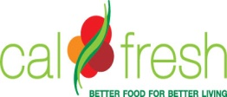

CalFresh Outreach Subcontractor Promising Practices Form

ORGANIZATION:

CONTACT NAME:

PHONE NUMBER:

EMAIL:

PRIME AGENCY:

REPORTING PERIOD:

Instructions
The purpose of this report is to elaborate on your CalFresh Program Access successes and promising practices during the reporting period.

Successes and Promising Practices
Please include successes and promising practices for your organization. Let us know what worked well for you, especially activities or processes that would help other organizations doing outreach.

You are not required to complete all the rows in the table below and you may add more rows if needed.

Success/Promising Practice | Outcome/Lessons Learned

